###### `

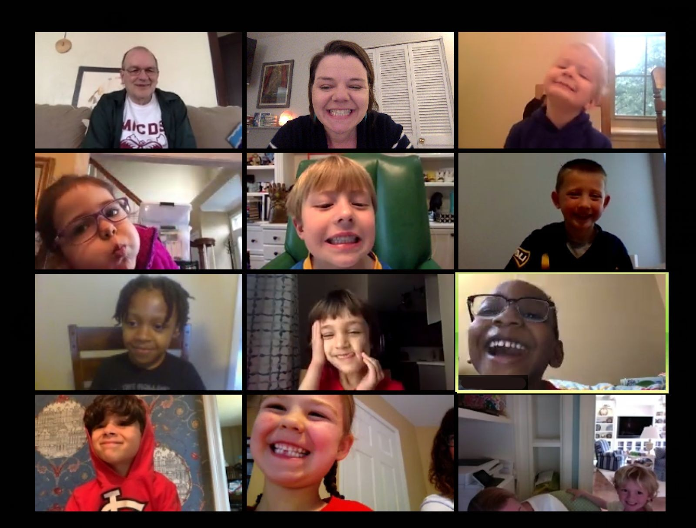Zoomminn

###### Problem Statement

Due to the pandemic, Most of the schools adopted online tools such as zoom to teach and interact with students. But these tools are not able to recreate the actual interactive experience for a teacher to manage the students. Create a student- teacher classroom experience for Zoom app to help teacher monitor and control the classroom teaching.

###### Why I chose this problem

1. Many people around such as parents/relatives/friends are teachers, who are finding it difficult to conduct online classes and have the first-hand experience with zoom classes. They are facing new age tech challenges that they’re not used to and are also not being trained (by the school administration).
2. 60% of the students aged between 8-15 years are facing ADD (Attention deficit disorder) and some psychological problems due to the continuous online classes.

#### Timeline

|  |  |
| --- | --- |
| **Phase** | **Time Box** |
| Desk Research | [06-11] 1-2 hour for each person |
| Primary Research | [07-11] 2 Hour for each person |
| Summarizing the research and finding the insights | [07-11] 4 hour all together |

|  |  |
| --- | --- |
| Making design documents like empathy map, persona journey map etc | [07-11] 1 hour for each person |
| Ideate | [07-11] 3-4 hours all together |
| Making wireframes | [08-11] 1 hour for each person |
| Discussing the wireframe | [08-11] 1 hour all together |
| Finalising the solution | 1 hour all together |
| Making High Fidelity Wireframes | 3-4 Hours |
| Review of HFW | 1 hour |
| Making Presentation | 1-2 Hours |

*\*Notes*

* 1. Almost all the activities took more time than expected
  2. After minor prototyping, I decided not to go for empathy mapping and persona because I am creating an intense journey map.

#### Desk Research

###### Teachers face challenges as online classes gather stem

|  |  |
| --- | --- |
| **Article/Source link** | https://bit.ly/3mYkWGA |
| **Factual / Statistical Insights** | 220 days and 1,320 hours to be reduced to 100 days and 600 hours for in-school sessions   * Remaining 100 days and 600 hours for active learning hours from home * 20 days likely to be set aside for sessions with doctors and counsellors to ensure well-being of students * Classes 1-5 likely to have classes twice a week * Classes 6-8 likely to attend classes 2-4 times a week * Classes 9-12 likely to attend classes 4-5 times a week * Class duration to reduce to 30 minutes |
| **Behavioural Insights**  **(Triggers/Barriers/etc.)** |  |

|  |  |
| --- | --- |
|  |  |

1. All the Schools across India move to Microsoft and Google after Govt. flags Zoom app.

|  |  |
| --- | --- |
| **Article/Source link** | https://bit.ly/2IgF1sO |
| **Factual / Statistical Insights** | Students and teachers also have their own struggles while accessing these online platforms. Due to financial constraints, students are not able to access the internet, and are devoid of electronic gadgets and laptop, phone or computer or even radio and TV. Those students who have facilities to attend to online classes face barriers in terms of unavailability of physical space, which is equally applicable to teachers who are supposed to conduct online classes from their home. There are also social barriers such as discrimination against girls as they are expected to do household chores instead of attending online classes in the mornings. In rural areas, boys are often expected to work on the family farmlands. In homes where TV and radio are available, the question of who has control over these gadgets is important. Most of the time, girls are not allowed to watch educational programmes. |

|  |  |
| --- | --- |
|  | When only 24 per cent of the households of students in India have internet access and in urban areas, 42 per cent of households have access to the internet as compared to 15 per cent in rural areas, this online education is catering to the needs of a chosen few. |
| **Behavioural Insights**  **(Triggers/Barriers/etc.)** | Most of the children using Zoom for attending online classes are usually unguarded and are too young to take the required technical precautions and safety measures as advised by the MHA,” stated Goyal in the letter to the UT Advisor. |

1. Peeping parents, sleeping students, bullying — online classes are a nightmare for teachers

|  |  |
| --- | --- |
| **Article/Source link** | https://bit.ly/3eBxlgG |
| **Factual / Statistical Insights** | Modern High issued a letter to parents, mentioning recent advisories by the government and requested teachers to use Google Docs while sharing documents.  From politicians to bureaucrats to private companies, all are concerned with completing the syllabus, assessing students and conducting entrance tests for medical and engineering courses through online mode in a haste, ignoring the issues and concerns of the marginalised section of the society. |
| **Behavioural Insights**  **(Triggers/Barriers/etc.)** | While teachers in private schools primarily complain about online bullying by students during video calls, their government counterparts claim the biggest challenge is reaching students who belong to the economically weaker section.  “There is no way of finding out who the student is during the Zoom call, so we have to ignore all the bullying and concentrate on teaching.” |

|  |  |
| --- | --- |
|  | Privacy- and propriety-related issues constitute a major concern among tutors. Some parents, teachers allege, record the lectures, while others “peep in”.  “I have faced issues where parents record lectures, then call me up to question me about the method of teaching. Also, it’s very awkward for the teacher to have the whole family watching you while teaching,” said Tripti Guha, who teaches at a private school in Baroda.  “It’s so difficult teaching young children online… their attention span is very short, it’s very difficult to make them sit through classes,” said a teacher who teaches Class 1 students at a Delhi private school. |

1. **Online education statistics**

|  |  |
| --- | --- |
| **Article/Source link** | https://bit.ly/352zrD8 |
| **Factual / Statistical Insights** | * Online education market in India was worth $ 247 million in 2016, which is expected to grow about $ 1.96 billion by 2021. That is a compound annual growth rate of 52%. * The number of users enrolled for various online learning courses is estimated to be 1.6 Million in 2016, Which is expected to grow about 9.6 Million by the end of 2021. * It is estimated that there is a 175% increase in the cost of classroom education, this gives online education more preferred because it is cost effective. * Nearly 48% of the population in India is between the 15–40 age group with high aspirations but lower income is a good target market for online education. And, the |

|  |  |
| --- | --- |
|  | acceptability of online channels is high in the younger demographic. |
| **Behavioural Insights**  **(Triggers/Barriers/etc.)** |  |

1. **Online education in 2021 statistics**

|  |  |
| --- | --- |
| **Article/Source link** | http s://bit.ly/3eANGlH |
| **Factual / Statistical Insights** |  |

|  |  |
| --- | --- |
|  |  |

|  |  |
| --- | --- |
| **Behavioural Insights**  **(Triggers/Barriers/etc.)** |  |

Competitive analysis

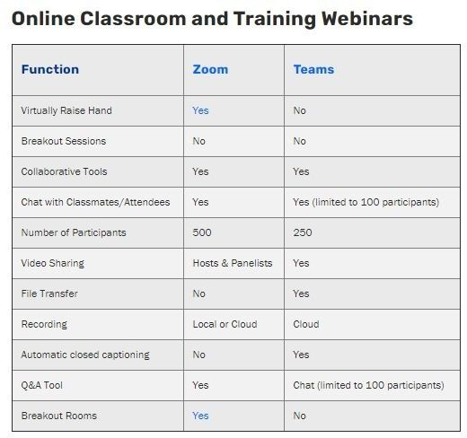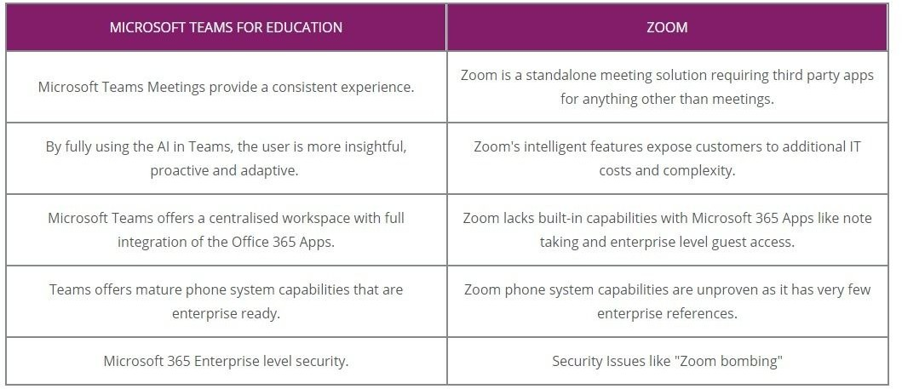

Features in Existing apps (Teams)

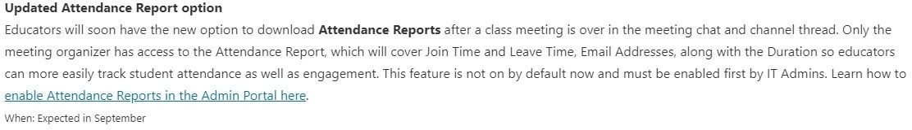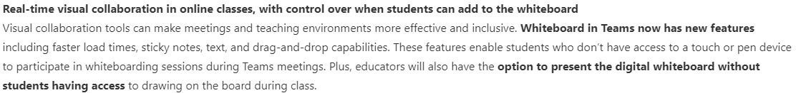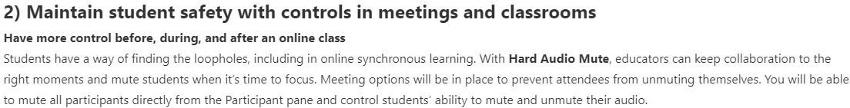

Fantronics - Classroom device monitoring system

Better Classroom Monitoring

Teachers can make use of the classroom monitoring feature, and monitor all the student activities in the class with a single glance from a central computer. As many as 3000

high-quality student thumbnails can be viewed in real time. This helps teachers to see all the classroom activities in a single picture and proceed with the lessons accordingly.

Eliminating Classroom Distractions

Teachers can blank out student screens to grab their attention instantly, and restrict their access to any website or applications if those are found to be inappropriate or irrelevant to the class. Thus, Faronics Insight eliminates the challenge of dealing with classroom distractions, such as instant messaging, video games, and website surfing, with a single click and brings the students’ focus back on the lesson.

Encouraging Collaborative Learning

This robust classroom management tool offers instructor-to-student and student-to-student screen sharing options, which make the classroom environment more conducive to learning. This enhances knowledge sharing and promotes collaborative ventures, which help the teachers provide a hands-on learning experience for the class.

Accelerating the Learning Process

With the help of Remote Control Feature, teachers can take total control of the students’ devices, to help them with a question or to provide one-to-one assistance. This not only helps the teachers to communicate with the students directly from their computers but also helps them to finish the coursework quickly.

Example of Gamification

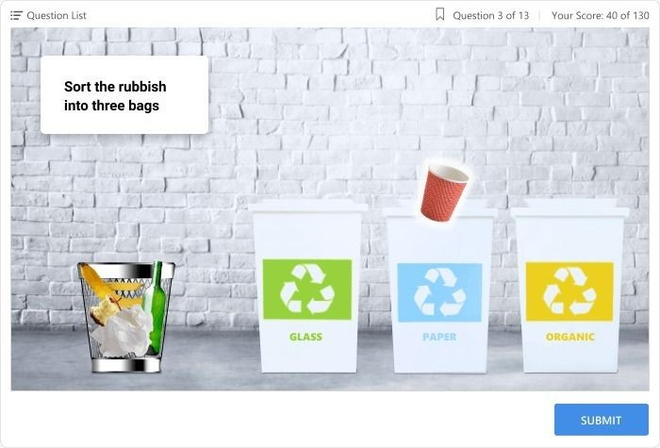

Summary

|  |  |
| --- | --- |
| Statistics | * The expected growth of online education will be about 2.6 billion in 2021 * There is 60% growth expected in the primary education in the channel of online education * 39 percentage of the online education will be focused on primary and secondary school sector in 2021 * The primary and secondary school sector is a highly potential market in india, only 3% of the potential market is accounted * Nearly 48% of the population in India is between the 15–40 age group with high aspirations but lower income is a good target   market for online education. And, the acceptability of online channels is high in the younger demographic.   * Private schools are proving the online classes now and the govt schools are using TV |
| Behavioral (Triggers, Barriers etc) | * Adapting technology took time for both students and teachers |

* Parents are hovering around the class is a issue
* Maintain the discipline in an online class is tough
* Zoom is losing customers because of security issues
* It is too difficult to teach young students through online classes their attention span is very less
* Students are sleeping in the class after turning off the audio and video

Target User

|  |  |
| --- | --- |
| **Product** | zoom |
| **Male:Female** | 50:50 |
| **Age** | 30-45 |
| **Occupation** | Primary/Secondary school teacher |
| **Population** | Teachers in the private schools using zoom, teachers in govt school using TV broadcasting. |
| **Type of Users** | We are focusing only one the urban/semi urban private school teachers as they are using zoom app. |

###### Primary Research

The primary research was mainly focused on the zoom related issues, as we get the more general perception in the secondary research. The secondary research not revealed the following

* + How teacher are conducting the online session, what are their preparation, what they do during the session and what they do after the sessions
  + How are they control their classes right now
  + How the students are behaving in the sessions
  + How teachers are evaluating students
  + What is the demographic of the students

Because of the shorter time span we interviewed the teachers through phone

###### User Interview:

**Joshna (9th grade Social Science teacher)**

|  |  |
| --- | --- |
| **Phone call** | As a TEACHER... |
| **Top 5 insights from** | * I would like to decide when students can leave the class. * I would like to hold the control over switching off the video * Zoom videos aren’t clear sometimes. I can’t notice   who logged in.   * Zoom names display something but the person who entered the class is different. * There’s no monitoring over teachers as in, when they logged in and how long the class went. |
| **understanding the** |
| **interactions and** |
| ***behaviour* wrt the** |
| **product** |
| **Top 5 insights from** | * Because I don’t want students to miss the class * Because I get feedback that students are listening to my class. * Because if I can’t see students, I don’t get   feedback   * Because I don’t want that unknown person to disturb my class |
| **understanding the *“WHY*** |
| ***user need them”* wrt to** |
| **the product** |

**Anju Teacher**

|  |  |
| --- | --- |
| **Phone call** |  |
| **Top 5 insights from** | * Students are doing so many different things while they are in the classroom * Some students may turn off the video and mute during calls * I am not able to identify the students comes with a nickname * Students are cheating in the exams and test i am conducting * I am using whatsapp for my primary   communication with the students |
| **understanding the** |
| **interactions and** |
| ***behaviour* wrt the** |
| **product** |
| **Top 5 insights from** | * I want to monitor the students activity so that i know that they are really listening * I want to evaluate the students with respect to their studies, I want to give more explanations to weaker students * I want to schedule my classes in advance * I want to conduct exams/quiz in the sessions |
| **understanding the** |
| ***decision making* wrt to** |
| **the product** |
| **Top 5 insights from** | * I like to have good quality call even with the students who have low connectivity * I would like to take the attendance automatically * I like to see the progress in the subject/course * I want to personally know my students. * I don't like anybody from their family interfere the learning session * I don't like students using their nicknames to come to my class |
| **understanding the *ideal*** |
| ***experience* wrt to the** |
| **product** |
| **Are there any verbatim/ quotes from the users that stood out for you?** | How will I know if they are sleeping or not? |

Grouping

**Primary school teacher**

|  |  |
| --- | --- |
| Give this Group of Users a Name  e.g. Trendsetters | Primary School Teachers |
|  | To collaborate and control their class room |
| Why do they use the product/ application?  Write the user goals as they would have described their goals and motivations | * Using zoom for the video class * Using for talking attendance * Want to do exams/test/assignments * They want to identify the student properly (now the nicknames makes the teacher difficult to understand the student) * Want to prevent student leaving without permission * Should be able to check the student is actually watching or not * Want to have how much time they spend on screen. |
| What information do they need to achieve these goals?  What features, benefits do they seek? | * Students info * Subject info * Class room info * Identify the students * Facility to engage the students * Individual attention * Who left the class * I want to prevent the students leave the session |
| What are the USP/ unique traits of this group and how do they differentiate from others? | Teachers want to have a seamless classroom experience, they want their students to be engaged and entertained. |

Journey Map

The primary and secondary research reveals certain insights about the teacher and students behaviour, but they are scattered. We arrange them into the form of a journey map to get more insight. We were trying to find the pain points and opportunities by plotting them into three stages “before class”, “during the class” and “after class”

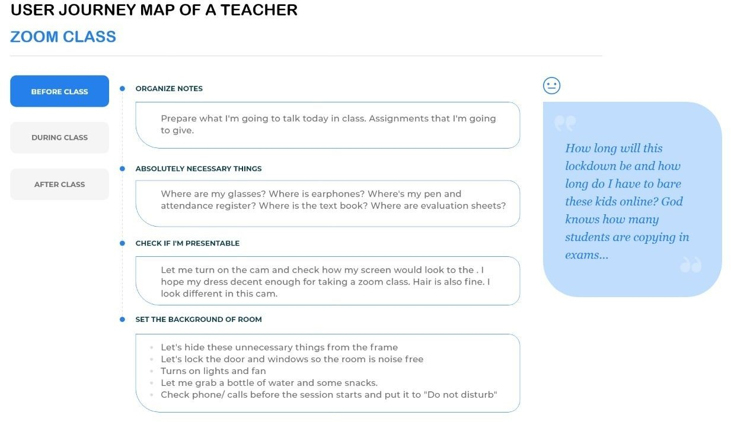

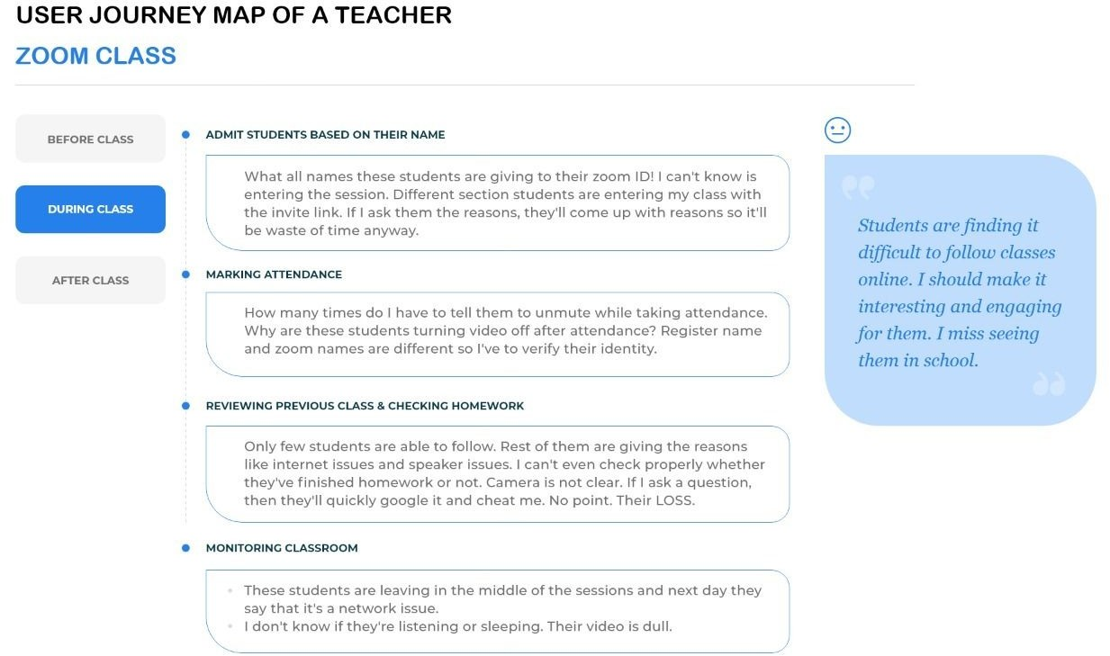

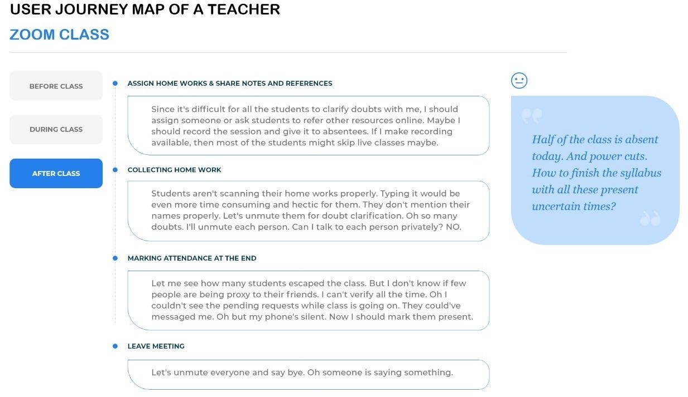

What I learned from the journey map

●

##### Note user challenges & frustrations that you identified

**1.**

Teacher as well as students missing their school days. It is very difficult for teachers to engage the students and students are not taking online classes seriously. Teacher missed the control over the class

**2.**

Teachers are admitting all the people who are coming to their sessions there is no possibility to identify the person.

**3.**

Teacher does not have any idea about what the student is doing. Some of them are sleeping, some of them playing games etc.

**4.**

There is no social interaction as they had in the school classroom. Teachers want to engage students to come to the class and stay focused.

**5.**

Students may leave the session as and when they feel to do so. The teacher cannot take any action about that.

**6.**

Teacher cannot find whether a student cheated in the exam or not

Convert these challenges into a HOW MIGHT WE QUESTIONS!

**1.**

How might we identify the students who come with a nickname?

**2.**

How might we monitor what individual students are doing?

**3.**

How might we provide some activity to students so that they can be engaged.

**4.**

How might we talk to a single student in session without disturbing others?

**5.**

How might we control students who are leaving the class without permission.

The ideas that I came up with

1. Student Identity through facial/retina scan
2. Introducing gamification to the students for engagement Eg: Cat watching students if they're not concentrating also to give some creative break to get engaged.
3. Private messages/notifications to each student/parent. Customized messages like:
   1. "Please concentrate on the class"
   2. "Don't be late to class" etc..
4. Control for teachers to decide when students can enter or leave the class.

## The Ideas I chose

* Private messages/notifications to each student/parent. Customized messages like:
  1. "Please concentrate on the class"
  2. "Don't be late to class" etc..
* Control for teachers to decide when students can enter or leave the class.
* Introducing gamification to the students for engagement

## Wireframes

Request to leave the meeting

Exit request for students host view

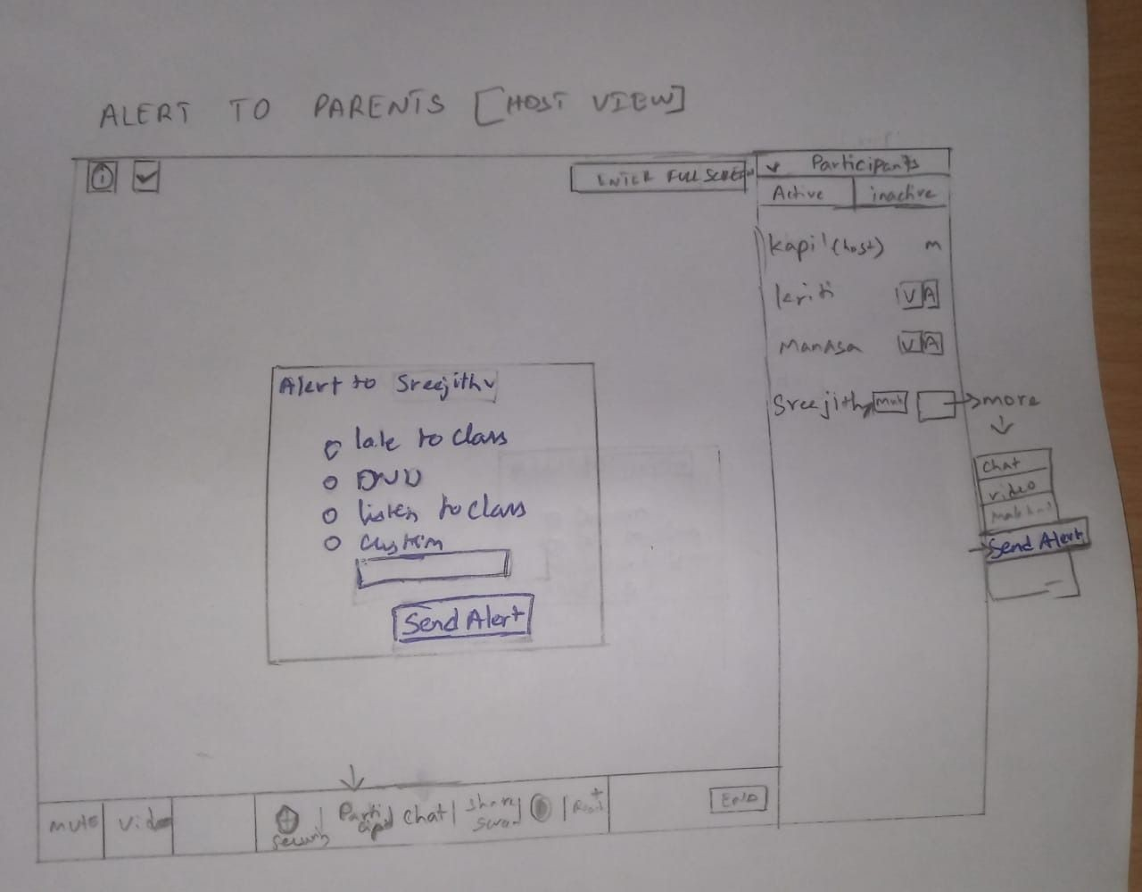Alert the parents

## Final Solution

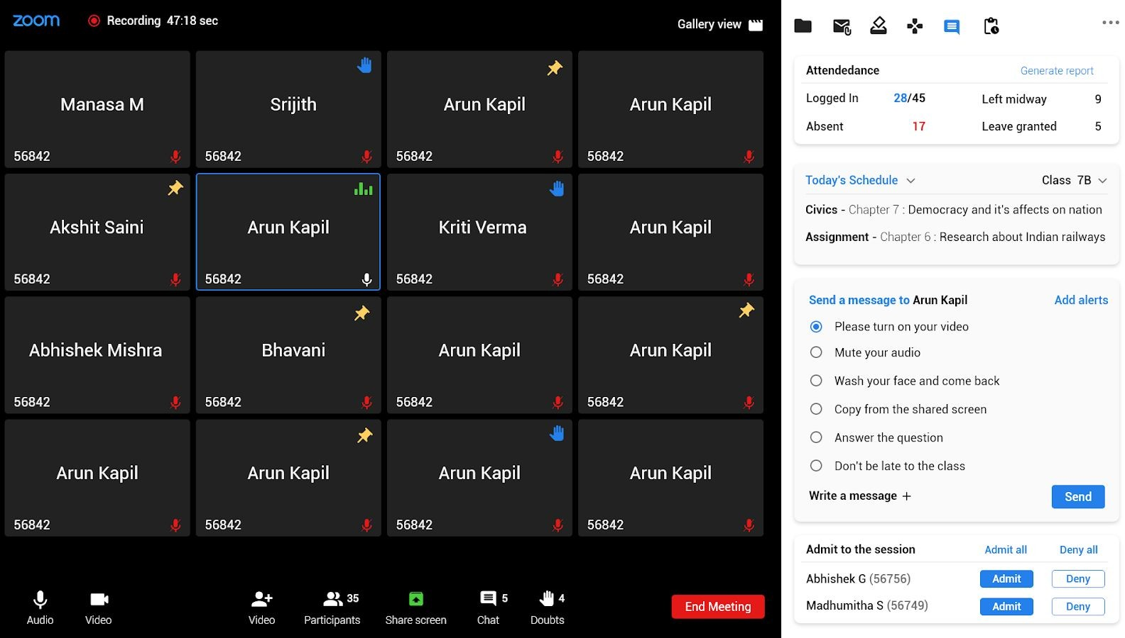

Recording 47:18 sec

Gallery view

56842

Manasa M

56842

Srijith

56842

Arun Kapil

56842

Arun Kapil

**Attendedance** Logged In Absent

**28**/**45**

**17**

Generate report

Left midway 9



Leave granted 5

Today's Schedule Class 7B

Akshit Saini

Arun Kapil

Kriti Verma

Arun Kapil

**Civics** - Chapter 7 : Democracy and it's affects on nation

**Assignment** - Chapter 6 : Research about Indian railways

56842

Abhishek Mishra

56842

56842

56842

Bhavani

56842

56842

Arun Kapil

56842

56842

Arun Kapil

**Send a message to Arun Kapil** Please turn on your video Mute your audio

Wash your face and come back Copy from the shared screen

Add alerts

56842

Arun Kapil

56842

Arun Kapil

56842

Arun Kapil

56842

Arun Kapil

Answer the question Don't be late to the class

**Write a message**

**Admit to the session**

Admit all

Send

Deny all

35 5 4

End Meeting

Abhishek G (56756)

Madhumitha S (56749)

Admit

Admit

Deny

Deny

Audio Video Video Participants Share screen Chat Doubts



Recording 47:18 sec

Gallery view

56842

Manasa M

56842

Srijith

56842

Arun Kapil

56842

Arun Kapil

**Attendedance** Logged In Absent

### 28/45

**17**

Generate report

Left midway 9



Leave granted 5

Today's Schedule Class 7B

Akshit Saini

56842

56842

ArunMKaadhpuiml itha S (56749) wantsKtorilteiavVeethrema class.

Reason: Not feeling w5e6ll8. 4I n2eed to take rest.

56842

Arun Kapil

**Civics** - Chapter 7 : Democracy and it's affects on nation

**Assignment** - Chapter 6 : Research about Indian railways

Allow Recording

**Send a message to Arun Kapil**

Please turn on your video

Add alerts

Abhishek Mishra

56842

56842

Bhavani

Allow DeAnyrun Kapil

56842

56842

Arun Kapil

Mute your audio

Wash your face and come back Copy from the shared screen

56842

Arun Kapil

56842

Arun Kapil

56842

Arun Kapil

56842

Arun Kapil

Answer the question Don't be late to the class

**Write a message**

**Admit to the session**

Admit all

Send

Deny all

35 5 4

End Meeting

Abhishek G (56756)

Madhumitha S (56749)

Admit

Admit

Deny

Deny

Audio Video Video Participants Share screen Chat Doubts



Recording 47:18 sec

Gallery view

56842

Manasa M

56842

Srijith

56842

Arun Kapil

56842

Arun Kapil

**Attendedance**

Logged In **28**/**45**



Absent **17**

**Games**

Generate report

Left midway 9

Leave granted 5

Akshit Saini

Arun Kapil

Kriti Verma

Arun Kapil

**Puzzles Chess**

56842

56842

56842

56842

Abhishek Mishra

Bhavani

Arun Kapil

Arun Kapil

**LUDO Quiz**

56842

56842

56842

56842

Arun Kapil

Arun Kapil

Arun Kapil

Arun Kapil

56842

56842

56842

56842

35 5 4

End Meeting

Audio Video Video Participants Share screen Chat Doubts



USER JOURNEY MAP OF A TEACHER ZOOM CLASS

ORGANIZE NOTES

BEFORE CLASS

DURING CLASS



*How long will this lockdown be and how long do I have to bare these kids online? God knows how many students are copying in exams...*

Prepare what I'm going to talk today in class. Assignments that I'm going to give.

ABSOLUTELY NECESSARY THINGS

CHECK IF I'M PRESENTABLE

Where are my glasses? Where is earphones? Where's my pen and attendance register? Where is the text book? Where are evaluation sheets?

Let me turn on the cam and check how my screen would look to the . I hope my dress decent enough for taking a zoom class. Hair is also ﬁne. I look different in this cam.

AFTER CLASS

SET THE BACKGROUND OF ROOM



Let's hide these unnecessary things from the frame

Let's lock the door and windows so the room is noise free Turns on lights and fan

Let me grab a bottle of water and some snacks.

Check phone/ calls before the session starts and put it to "Do not disturb"

# USER JOURNEY MAP OF A TEACHER ZOOM CLASS

ADMIT STUDENTS BASED ON THEIR NAME

BEFORE CLASS

DURING CLASS



*Students are finding it difficult to follow classes online. I should make it interesting and engaging for them. I miss seeing them in school.*

What all names these students are giving to their zoom ID! I can't know is entering the session. Different section students are entering my class with the invite link. If I ask them the reasons, they'll come up with reasons so it'll be waste of time anyway.

MARKING ATTENDANCE

How many times do I have to tell them to unmute while taking attendance. Why are these students turning video off after attendance? Register name and zoom names are different so I've to verify their identity.

AFTER CLASS

REVIEWING PREVIOUS CLASS & CHECKING HOMEWORK

Only few students are able to follow. Rest of them are giving the reasons like internet issues and speaker issues. I can't even check properly whether they've ﬁnished homework or not. Camera is not clear. If I ask a question, then they'll quickly google it and cheat me. No point. Their LOSS.

MONITORING CLASSROOM



These students are leaving in the middle of the sessions and next day they say that it's a network issue.

I don't know if they're listening or sleeping. Their video is dull.

USER JOURNEY MAP OF A TEACHER ZOOM CLASS

ASSIGN HOME WORKS & SHARE NOTES AND REFERENCES

BEFORE CLASS

DURING CLASS

*Half of the class is absent today. And power cuts. How to finish the syllabus with all these present*

Since it's difﬁcult for all the students to clarify doubts with me, I should assign someone or ask students to refer other resources online. Maybe I should record the session and give it to absentees. If I make recording available, then most of the students might skip live classes maybe.

COLLECTING HOME WORK

Students aren't scanning their home works properly. Typing it would be even more time consuming and hectic for them. They don't mention their names properly. Let's unmute them for doubt clariﬁcation. Oh so many doubts. I'll unmute each person. Can I talk to each person privately? NO.

AFTER CLASS

MARKING ATTENDANCE AT THE END

Let me see how many students escaped the class. But I don't know if few people are being proxy to their friends. I can't verify all the time. Oh I couldn't see the pending requests while class is

LEAVE MEETING

Let's unmute everyone and say bye. Oh someone is saying something.